**1.What is software testing?**

Software Testing is a process used to identify the correctness, completeness, and quality of developed computer software.

**2. What is Exploratory Testing?**

• Exploratory testing is a concurrent process where

• Test design, execution and logging happen simultaneously

• Testing is often not recorded

• Makes use of experience, heuristics and test patterns

• Testing is based on a test charter that may include

• Scope of the testing (in and out)

• The focus of exploratory testing is more on testing as a “thinking” activity.

• A brief description of how tests will be performed

• Expected problems

• Is carried out in time boxed intervals

• More structured than Error guessing

**3. What is traceability matrix?**

Traceability Matrix is also known as Requirement Traceability Matrix . RTM is a table which is used to trace the requirements during the Software development life Cycle. It can be used for forward tracing (i.e. from Requirements to Design or Coding) or backward (i.e. from Coding to Requirements). There are many user defined templates for RTM.

**4. What is Boundary value testing?**

Boundary value analysis is a methodology for designing test cases that concentrates software testing effort on cases near the limits of valid ranges

Boundary Value Analysis (BVA) uses the same analysis of partitions as EP and is usually used in conjunction with EP in test case design.

**5. What is Equivalence partitioning testing?**

The numbers fall into a partition where each would have the same, or equivalent, result is called Equivalence partitioning testing.

**6. What is Integration testing?**

Integration testing is associated with the architectural design phase.

Integration tests are performed to test the coexistence and communication of the internal modules within the system.

**7. What determines the level of risk?**

**8. What is Alpha testing?**

Internal Acceptance Testing is also known as Alpha Testing. It is performed by members of the organization that developed the software but who are not directly involved in the project.

Type of testing a software product or system conducted at the developer's site. Usually it is performed by the end user.

**9. What is beta testing?**

User Acceptance Testing (Also known as Beta Testing) is performed by thenend users of the software. They can be the customers themselves or the customers’ customers.

• It is always performed by the customers at their own site.

• It is not performed by Independent Testing Team.

• Beta Testing is always open to the market and public.

• It is usually conducted for software product.

• It is performed in Real Time Environment.

• It is always performed outside the organization.

• It is also the form of Acceptance Testing.

• Beta Testing (field testing) is performed and carried out by users or you can say people at their own locations and site using customer data.

• It is only a kind of Black Box Testing.

**10. What is component testing?**

The testing of individual software components

It is also known as unit testing.

component testing is more likely to find coding logic defects than system design defects.

Testing technique similar to unit testing but with a higher level of

integration - testing is done in the context of the application instead of just directly testing a specific method. Can be performed by testing or development teams.

**11. What is functional system testing?**

Testing based on an analysis of the specification of the functionality of a component or system.

**12. What is Non-Functional Testing?**

Testing the attributes of a component or system that do not

relate to functionality.

**13. What is GUI Testing?**

GUI Testing means User Interface Testing.

It is also known as graphical user interface.

Graphical User Interface (GUI) testing is the process of testing the system’s GUI of the System under Test. GUI testing involves checking the screens with the controls like menus, buttons, icons, and all types of bars – tool bar, menu bar, dialog boxes and windows etc.

**14. What is Adhoc testing?**

Adhoc testing is an informal testing type with an aim to break the system.It does not follow any test design techniques to create test cases.

Adhoc Testing does not follow any structured way of testing and it is randomly done on any part of application.

Main aim of this testing is to find defects by random checking

**15. What is white box testing and list the types of white box testing?**

Testing based on an analysis of the internal structure of the

component or system.

Structure-based testing technique is also known as ‘white-box’ or ‘glass-box’ testing

There are five types of white box testing:

Branch Condition testing

Branch Condition Combination testing

Modified Condition Decision testing

Dataflow testing

Linear Code Sequence And Jump (LCSAJ) testing

**16. What is black box testing? What are the different black box testing techniques?**

Testing, either functional or non-functional, without reference to the

internal structure of the component or system.

There are four black-box technique:

• Equivalence partitioning

• Boundary value analysis

• Decision tables

• State transition testing

• Use-case Testing

• Other Black Box Testing

• Syntax or Pattern Testing

**17. Mention what are the categories of defects?**

• It can be of two types of defects.

• Defect from the product or a variance from customer/user expectations.

• It is a flaw in the software system and has no impact until it affects the user/customer and operational system.

**18. Mention what bigbang testing is?**

Big Bang Integration Testing is an integration testing strategy where in all units are linked at once, resulting in a complete system. When this type of testing strategy is adopted, it is difficult to isolate any errors found, because attention is not paid to verifying the interfaces across individual units.

**19. What is the purpose of exit criteria?**

Purpose of exit criteria is to define when we STOP testing either at the:

• End of all testing

• End of phase of testing

**20. When should "Regression Testing" be performed?**

Regression testing should be carried out:

• when the system is stable and the system or the environment changes

• when testing bug-fix releases as part of the maintenance phase

• It should be applied at all Test Levels

• It should be considered complete when agreed completion criteria for regression testing

have been met

• Regression test suites evolve over time and given that they are run frequently are ideal

candidates for automation

**21. What is 7 key principles? Explain in detail?**

**• Testing shows presence of Defects:**

In thistesting we can show that error are present, but cannot prove that there are no errors.

We test to find faults.

**• Exhaustive Testing is Impossible:**

Testing everything including all combinations of inputs and preconditions is not

Possible

**• Early Testing:**

Testing activities should start as early as possible in the software or system development life cycle, and should be focused on defined objectives.

**• Defect Clustering:**

small number of modules contain most of the defects discovered during pre-release testing, or are responsible for the most operational failures.

 Defects are not evenly spread in a

System.

**• The Pesticide Paradox:**

If the same tests are repeated over and over again, eventually the same set of test cases will no longer find any new defects.

Testing identifies bugs, and programmers respond to fix them

**• Testing is Context Dependent:**

Testing is done differently in different contexts

 Different kinds of sites are tested differently.

**• Absence of Errors Fallacy:**

If the system built is unusable and does not fulfill the user’s needs and expectations then

finding and fixing defects does not help.

It doesn’t make it a good system.

**22. Difference between QA v/s QC v/s Tester**

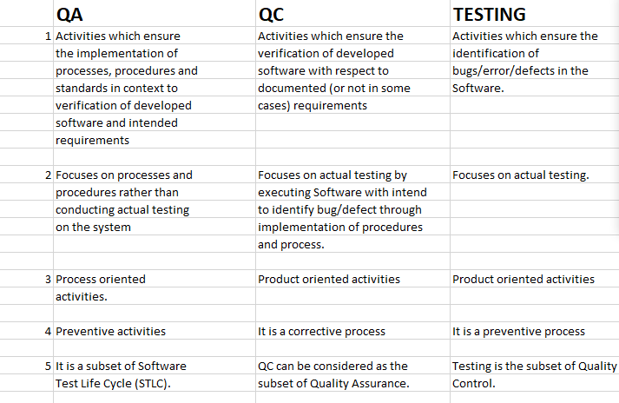

**23. Difference between Smoke and Sanity?**

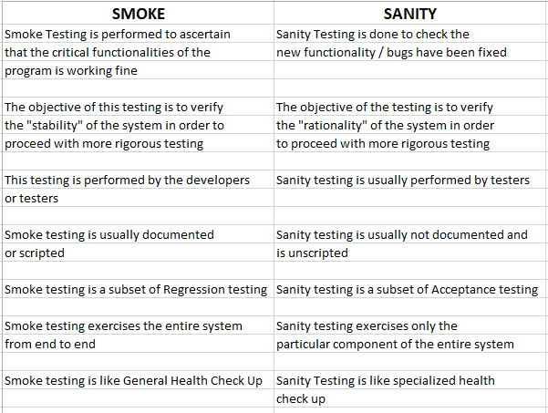

**24. Difference between verification and Validation**

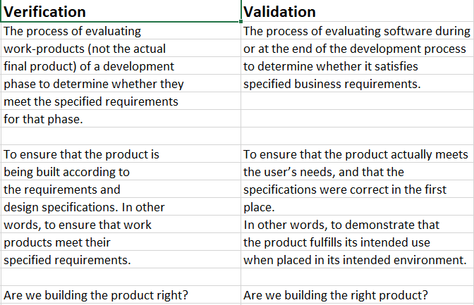

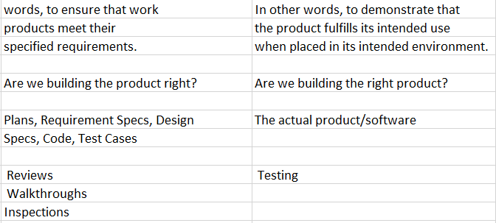

**25. Explain types of Performance testing.**

• **Load testing :**

It is a performance testing to check system behavior under load. Testing an application under heavy loads, such as testing of a web site under a range of loads to determine at what point the system’s response time degrades or fails.

• **Stress testing :**

Stress testing is to test the system behaviour under extreme conditions and is carried out till the system failure.

• **Endurance testing :**

Type of testing which checks for memory leaks or other problems that may occur with prolonged execution. It is usually performed by performance engineers.

• **Spike testing :**

• **Volume testing :**

Testing which confirms that any values that may become large over time (such as accumulated counts, logs, and data files), can be accommodated by the program and will not cause the program to stop working or degrade its operation in any manner. It is usually

conducted by the performance engineer.

• **Scalability testing :**

Part of the battery of non-functional tests which tests a software application for measuring its capability to scale up - be it the user load supported, the number of transactions, the data volume etc. It is conducted by the performance engineer.

**26. What is Error, Defect, Bug and failure?**

A mistake in coding is called error, error found by tester is called defect, defect accepted by development team then it is called bug, build does not meet the requirements then it is failure.

**27. Difference between Priority and Severity**

Severity is how seriously the bug is affecting the application. The severity type is defined by the tester based on the written test cases and functionality.

Priority is the order in which developer has to fix the bug. If high priority is mentioned then the developer has to fix it at the earliest. The priority status is set based on the customer requirements.

**28. What is Bug Life Cycle?**

Bug life cycle is nothing but the various phases a bug under goes after it is raised or reported.

The different phases of Bug life cycle are,

- New or Opened

- Assigned

- Fixed

- Tested

- Closed

**29. Explain the difference between Functional testing and NonFunctional testing**

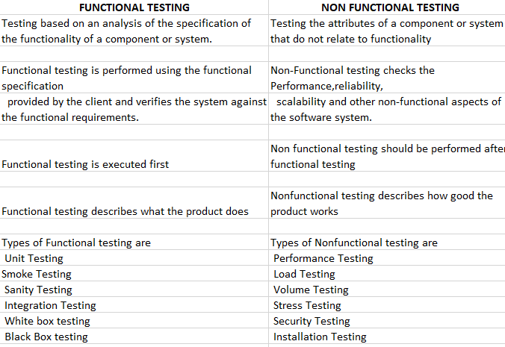

** To create HLR & TestCase of**

**1) (Instagram , Facebook) only first page**

**2) Facebook**

**HLR of instagram:**

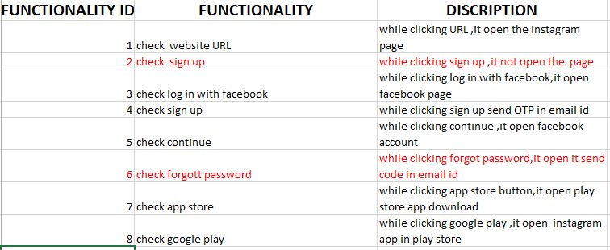

**HLR OF FACEBOOK**

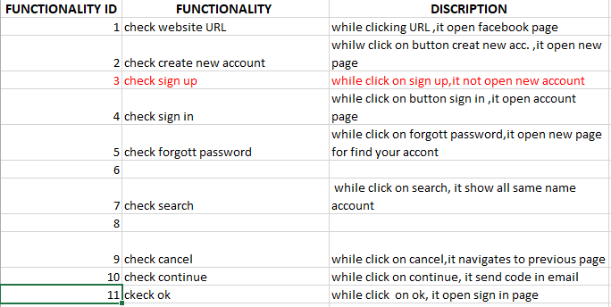

**What is the difference between the STLC (Software Testing Life Cycle) and SDLC (Software Development Life Cycle)?**

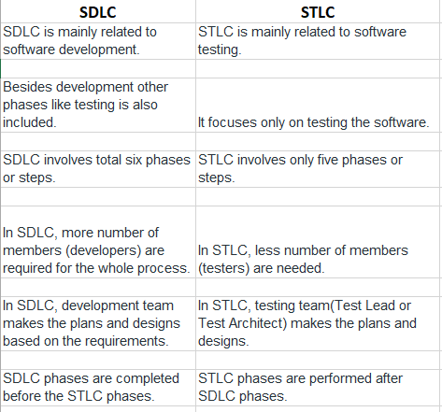

**32. What is the difference between test scenarios, test cases, and test script?**

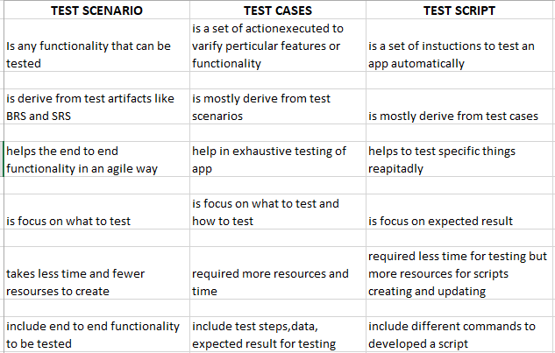

**33. Explain what Test Plan is? What is the information that should be covered.**

A Test Plan refers to a detailed document that catalogs the test strategy, objectives, schedule, estimations, deadlines, and the resources required for completing that particular project. Think of it as a blueprint for running the tests needed to ensure the software is working properly – controlled by test managers.

**34.What are the different Methodologies in Agile Development Model?**

There are 5 main Agile methodologies:

Scrum, Kanban, Extreme Programming (XP), Lean Development e Crystal.

**35.Explain the difference between Authorization and Authentication in Web testing.**

 Authentication is the process of verifying who someone is, whereas authorization is the process of verifying what specific applications, files, and data a user has access to

**36.What are the common problems faced in Web testing?**

Integration. Integration testing exposes problems with interfaces among different program components before deployment.

Interoperability.

Security.

Performance.

Usability.

Quality Testing, Exceptional Services. Etc..

**37. To create HLR & TestCase of WebBased (WhatsApp web , Instagram) 1. WhatsApp Web :** [**https://web.whatsapp.com/**](https://web.whatsapp.com/)

**HLR of whatsapp:**

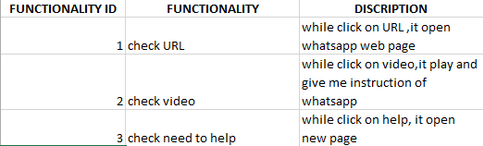

**Test case of whatsapp web:**

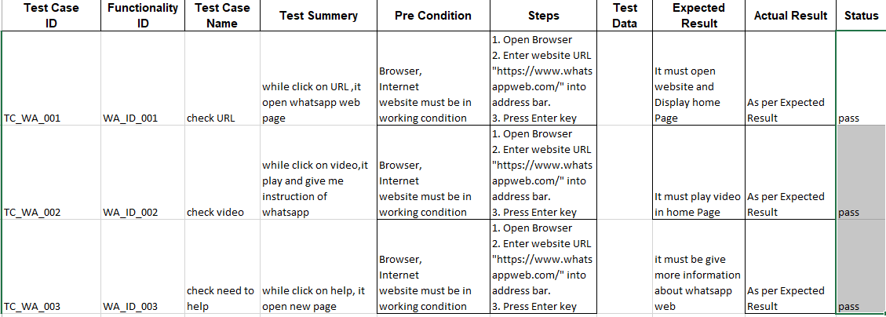

**HLR of instagram:**

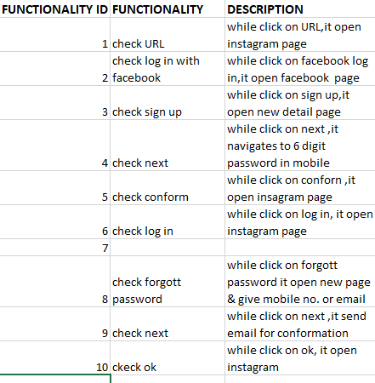

**Test case of instagram:**

